Assignment: AI-Assisted Landing Page Development for FDE Service

Objective
The goal of this assignment is to assess learners' ability to:
- Use AI coding assistants for software development.
- Compare outputs from different AI models.
- Identify AI-generated code quality issues.
- Detect AI hallucinations and incorrect assumptions.
- Apply human judgment during AI-assisted development.

Task Description
You are required to develop a professional landing page for an FDE (Forward Deployed Engineer) Service using AI-assisted coding tools.
You must use at least two different AI models/tools and compare their outputs.
Examples:
- Claude Code
- ChatGPT
- Gemini
- GitHub Copilot
- Other AI coding assistants

Required Documentation
Create:
observation.md

observation. md Format

1. AI Models Used
Example:
Model 1:
Claude Code- Opas 4.5
Model 2:
ChatGPT

2. Prompt Used
Write the prompts you provided to each AI model.
Example:
"Create a responsive landing page for an FDE service using HTML and CSS."

3. Code Quality Observation
Compare:
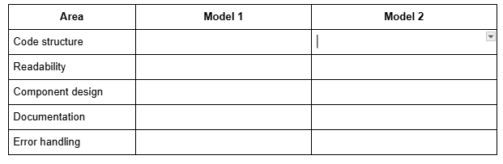

4. AI Hallucination Observation
Identify cases where AI generated incorrect information.
Example:
Observation:
The AI created a fake API endpoint:
https://api.example-ai-service.com
The endpoint does not exist and requires human verification.

5. Final Decision
Answer:

Which AI model produced better results and why?
Consider:
- Code quality
- Accuracy
- Maintainability
- Understanding of requirements

Submission Guideline:
- Submit a public GitHub repository link.

